Name: ______________________________ Date: ___/___/_____ Class Period:#___

Rikki-Tikki-Tavi by Rudyard Kipling

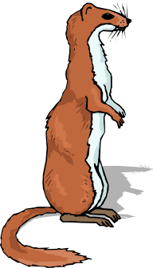
- As you read the short story, “Rikki-Tikki-Tavi,” notice the conflict between the cobra and the mongoose, two natural enemies.
- Using your material and knowledge gained of the animals in the paired texts, fill in the chart below. Write down the characteristics of a mongoose and a cobra.

If you have a smart device in class, you may also use the following webpages:

- http://www.encyclopedia.com/topic/mongoose.aspx
- http://www.encyclopedia.com/topic/cobra.aspx

Comparison Chart

Animal | Habitat | Size | Description of what it looks like | Value to Society
Mongoose

Cobra

Vocabulary in Context

Directions: Complete the following chart:

Words in Context | What I Predict the Highlighted Word Means | Dictionary Check of What the Word Means
One day, a high summer flood washed him out of the burrow where he lived with his father and mother, and carried him, kicking and clucking, down a roadside ditch. He found a little wisp of grass floating there, and clung to it till he lost his senses. When he revived, he was lying in the hot sun in the middle of a garden path, …
…he was lying in the hot sun on the middle of a garden path, very draggled indeed, and a small boy was saying: “Here’s a dead mongoose. Let’s have a funeral.”
There, in the warm litter about the melons, very cunningly hidden, he found twenty-five eggs, about the size of a bantam’s eggs…
…and then Teddy’s mother picked him up from the dust and hugged him, crying that he had saved Teddy from Death, and Teddy’s father said that he was a providence, and Teddy looked on with big scared eyes.
At the bottom of the smooth plaster wall there was a brick pulled out to make a sluice for the bath water, and as Rikki-tikki stole in by the masonry curb where the bath is put, he heard Nag and Nagaina whispering together outside in the moonlight.
…Rikki braced his back against the bulge of the red earthenware to hold down the head. This gave him just one second’s purchase, and he made the most of it.
Where is Nagaina… On the rubbish heap by the stables, mourning for Nag.
Well! It may be some consolation to you when you’re dead to know that I shall settle accounts with the boy.

Prediction
Directions: Preview the pictures and captions in the short story, “Rikki-Tikki-Tavi.” Read the first paragraph. Then, write a two-sentence prediction telling what you think will happen in the story next.
__________________________________________________________________________________________
__________________________________________________________________________________________
__________________________________________________________________________________________
__________________________________________________________________________________________

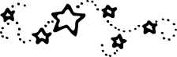

Student’s Name: ____________________________________ Date: ____________________

Title: ______________________________________ Author: _________________________

- Did you feel like you were part of the story? Yes No
Explain your answer.

- Were you able to guess what was going to happen at the end? Yes No
Explain your answer.

- What do you think was the best part of the story?

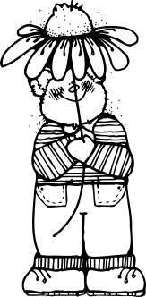
Conflict List
(Check one or more)

❑ Character vs. Nature
❑ Character vs. Self
❑ Character vs. Society
❑ Character vs. Character
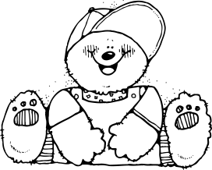

- What was the main problem in the story?

- What was the character’s goal?

- How was the problem solved? (Resolution/Solution)

